
KITH AND KIN INTERNATIONAL COLLEGE

7/11 Kaoli Olusanya Street, Owode Ibeshe, Ikorodu, Lagos State.
THIRD TERM EXAMINATION 2024/2025 ACADEMIC SESSION

NAME
SUBJECT | AGRICULTURAL SCIENCE | CLASS | JSS1 | DURATION | 1 HOUR 30MINS

PART 1- OBJECTIVES
INSTRUCTION- Attempt all questions (50 Marks)

1. The following are factors of production EXCEPT
A. Land
B. Labour
C. Capial
D. Investment
2. One of the following is a reward for land
A. profit
B. rate
C. interest
D. wages
3. Hoe is a farm tool used for
A. pruning
B. transplanting seedlings
C. ridges making
D. applying insecticides
4. One of the following is NOT a method of controlling weed
A. physical
B. electrical
C. chemical
D. biological
5. The common name for weed: Imperata cylindrica is:
A. elephant grass
B. stubborn grass
C. spear grass
D. lemon grass
6. A monocotyledonous plant is a plant that has ------- cotyledon(s)
A. five
B. two
C. one
D. three
7. One of the functions of the leaf to plant is to
A. develop into flower
B. develop into a seed
C. form the root system
D. manufacture food for plant
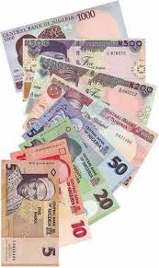

8. The following are agricultural uses of capital EXCEPT
- wages
- establishment of farm enterprise
- payment of debt
- running of day-day activities.
9. The breeds of cattle which are used for the production of milk are called
A. prestige animals
B. beef animals
C. diary animals
D. pet animals
10. The branch of agriculture that deals with the production of fruits, vegetables and ornamental plants is called
A. agronomy
B. soil science
C. forestry
D. horticulture
11. The following are simple farm tools EXCEPT
A. fork
B. sickle
C. cutlass
D. hoe
12. Any plant growing where it is not wanted is called ----
A. weed
B. cereal
C. seed
D. legume
13. The type of agriculture in which a farmer plant crops and rear animals for himself and his family is called ------------
A. subsistence agriculture
B. compost agriculture
C. commercial agriculture
D. pastoral agriculture
14. The process by which green plants manufacture their food in the presence of carbon dioxide, water and sunlight is called --------------
A. pollination
B. photosynthesis
C. oxidation
D. fertilization
15. The following are branches of agriculture except
A. crop science
B. animal science
C. forestry
D. fishery

16. Agriculture provides all these benefits EXCEPT
A. food
B. clothing
C. shelter
D. rocks
17. A crop which requires two growing seasons to reach maturity is called ------------ crop
A. forage
B. cereals
C. annual
D. biennial
18. What is the name of the farm tool shown below?
A. Head pan
B. Sickle
C. Shovel
D. Watering can
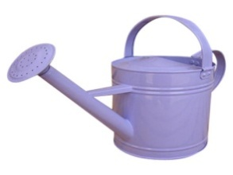
19. A typical plant is made up of ------------- and -----------
A. leaves and branches
B. leaves and roots
C. root and shoot system
D. fruits and flowers
20. The transfer of pollen grains from the anther to the stigma of a flower is called ----------
A. photosynthesis
B. pollination
C. ovulation
D. fertilization
21. Hunting of animals and gathering of fruits are traced back to
A. nomads
B. early men
C. ancestors
D. Oyo Empire
22. Which of the following is a raw material for the textile industry?
A. Cocoa
B. Cotton
C. Millet
D. Rubber
23. All the following are agricultural weeds EXCEPT
A. Cocoa
B. Tridax
C. Spear grass
D. Stubborn grass
24. Weeds can be used for the following EXCEPT
A. Food for man
B. Feeding farm animals
C. Increased crop yield
D. Drugs
25. The word agriculture is coined from two Latin words: ---------- and ------------
A. land, ager
B. cultivation, field
C. ager, cultura
D. ager, cultivation
26. Which of these branches of agriculture below is concerned with the diffusion of agricultural innovation?
A. Agricultural economics
B. Agricultural engineering
C. Agricultural extension
D. Animal husbandry
27. The shoot system is made up of ------------
A. leaves, stem and root
B. leaves, shoot and stem
C. stem, flowers and leaves
D. leaves, flowers and shoot
28. The distance between two nodes on a plant is called --------
A. bud
B. internode
C. radical
D. apex
29. Cereal crops include the following EXCEPT
A. Groundnut
B. Cowpea
C. Rice
D. Maize
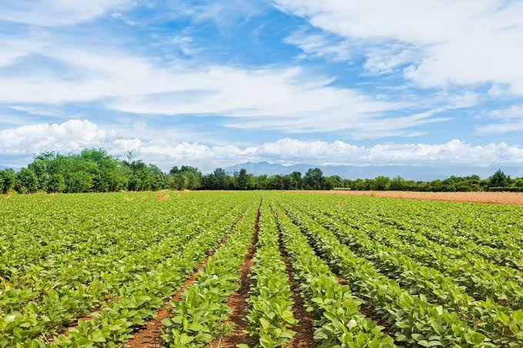
30. The following are agricultural uses of land EXCEPT
A. Hospital.
B. Rearing animal
C. Planting of crops
D. Fish pond.
31. Beverage industries use ------------- to manufacture beverages
A. kenaf
B. cotton
C. jute
D. cocoa
32. After pollination and fertilization, ----------- develops into fruit
A. ovary
B. stem
C. root
D. bud
33. One of the functions of stem is to:
A. anchor the plant to the soil
B. absorb water and mineral salts from the soil
C. conduct water and mineral salts to the leaves
D. manufacture food for the plant
34. The field of agriculture concerned with the study and control of pests and diseases of livestock is called -----
A. soil science
B. crop science
C. botany
D. veterinary medicine
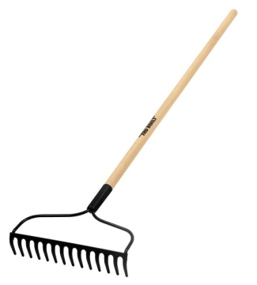
35. The figure above is used for ------------
A. felling trees
B. removing large stumps
C. transplanting seedlings
D. smoothening soil surface
36. One of the following is an annual crop
A. cocoa
B. maize
C. pawpaw
D. citrus
37. All the following are common weeds EXCEPT
A. Goat weed
B Sheep weed
C. Tridax
D. Water leaf
38. The green colouring matter present in leaves of plant is called -----------
A. chlorophyll
B. nucleus
C. cytoplasm
D. vacuole
39. Poultry refers to the following EXCEPT
A. Fowl
B. Sheep
C. Turkey
D. Goose
40. The following are important oil producing crops EXCEPT
A. Groundnut
B. Coconut
C. Oil Palm
D. Cucumber
41. All the following are the ways of maintaining farm tools except
A. Tools must be stored in a cool dry place
B. Wooden parts of the tools must be painted
C. tools with bolt and nut must be tightened before working
D. tools must be kept inside the rain
42. Farm tool used for harvesting cereals is -------
A. sickle
B. hoe
C. axe
D. rake
43. Beverage industries use ------------- to manufacture beverages
A. kenaf
B. cotton
C. jute
D. cocoa
44. Classification of weeds based on life cycle include the following EXCEPT
A. perennial
B. biennial
C. annual
D. Ephemeral
45. After pollination and fertilization, ----------- develops into seed
A. ovule
B. stem
C. root
D. bud
46. One of the functions of stem is to:
A. anchor the plant to the soil
B. absorb water and mineral salts from the soil
C. conduct water and mineral salts to the leaves
D. manufacture food for the plant
47. The field of agriculture concerned with the study and control of pests and diseases of livestock is called -----
A. soil science
B. crop science
C. botany
D. veterinary medicine

48. The skeleton of cartilaginous fishes is made of a firm, shiny and elastic substance called -------
A. cartilage
B. muscles
C. tendon
D. bones
49. The figure above is used for ------------
A. felling trees
B. removing large stumps
C. transplanting seedlings
D. smoothening soil surface
50. All the following are types of fishing nets EXCEPT
A. seine nets
B. cast and throw nets
C. gill net
D. leather net

PART II- THEORY
INSTRUCTION: Answer any four questions from this parts (40 marks)
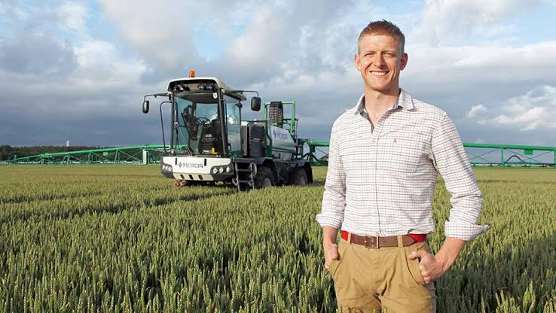

The above image is for Mr. John, the farm manager at Kith and Kin International College.
Use it to answer question number 1

1a. Mention four functions of Mr. John as a farm manager. 4marks
b. List four features of management. 4marks
c. What is management? 2marks

2. Use the image below to answer question number 2


a. State three features of the above image as a factor of production. 3marks
b. Highlight its three importance in agriculture. 3marks
c. Classify the following as working capital and fixed capital.
Cash in hand, tractor, cash in bank, feeds, drugs, hoe, farm store, poultry house. 4marks
S/N | FIXED CAPITAL | WORKING CAPITAL
1
2
3
4

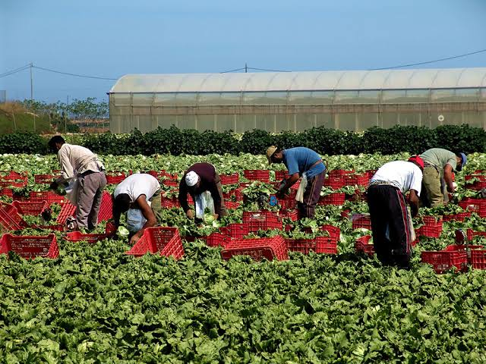
In the picture above, there are farm labourers working for Mr. Kehinde. Use the information to answer question number 3

3a. State four features of the labour in the above image. 4marks
b. As a factor of production, how many forms of labour do we have? Mention them. 3marks
c. Highlight three types of labour. 3marks

4. The image below represents land as a factor of production.
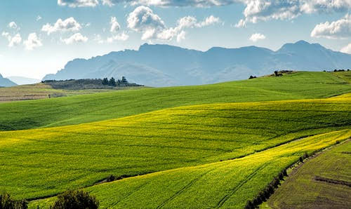
a. State four importance of land in agriculture as a factor of production. 4marks
b. Highlight four features of land as a factor of production. 4marks
c. Mention four non agricultural use of land. 2marks

5a. Define weed. 2marks
b. List four effects of weeds on crops. 4marks
c. Mention four ways of controlling weeds. 4marks

